**Spring REST using Spring Boot 3**

**2. spring-rest-handson**

**Hello World RESTful Web Service**

* **src/main/java/com/cognizant/spring_learn/controller**

**HelloController.java**

package com.cognizant.spring_learn.controller;

import org.slf4j.Logger;

import org.slf4j.LoggerFactory;

import org.springframework.web.bind.annotation.GetMapping;

import org.springframework.web.bind.annotation.RestController;

@RestController

public class HelloController {

private static final Logger *LOGGER* = LoggerFactory.*getLogger*(HelloController.class);

@GetMapping("/hello")

public String sayHello() {

*LOGGER*.info("START");

String message = "Hello World!!";

*LOGGER*.info("END");

return message;

}

}

* **src/main/resources**

**application.properties**

server.port=8083

spring.application.name=spring-learn

logging.level.com.cognizant.spring_learn=DEBUG

* **SpringLearnApplication.java**

package com.cognizant.spring_learn;

import org.slf4j.Logger;

import org.slf4j.LoggerFactory;

import org.springframework.boot.SpringApplication;

import org.springframework.boot.autoconfigure.SpringBootApplication;

@SpringBootApplication // Enables component scanning and auto-configuration

public class SpringLearnApplication {

private static final Logger *LOGGER* = LoggerFactory.*getLogger*(SpringLearnApplication.class);

public static void main(String[] args) {

*LOGGER*.info("START");

SpringApplication.*run*(SpringLearnApplication.class, args); // Launch Spring Boot app

*LOGGER*.info("END");

}

}

Then go to:

[**http://localhost:8083/hello**](http://localhost:8083/hello)

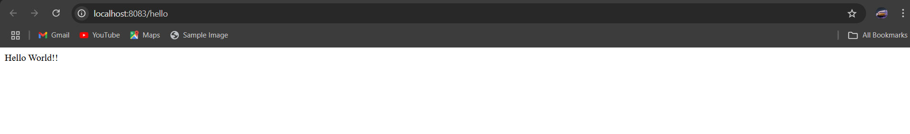

In network tab of developer tools show the HTTP header details received

**Chrome Browser:**

1. Press F12 to open **DevTools**.
2. Go to **Network tab**.
3. Refresh the browser with the /hello endpoint.
4. Click on the /hello request → Go to **Headers tab**.

Look for:

* **Request URL:** http://localhost:8083/hello
* **Request Method:** GET
* **Status Code:** 200 OK
* **Content-Type:** text/plain;charset=UTF-8
* **Server:** Spring Boot